Order Of Service

Singing: Psalm 62—CW page 88

Reading: Psalm 34

Opening Hymn: CW 260

Reading: Revelation 16

Request Hymn: CW Supplement 750

Reading: John 8:12-20

Sermon Hymn: CW 256

Sermon Text: Song Of Solomon 5:12

His Eyes

Prayer

The Apostles’ Creed, TLH page 12

Holy Communion

The Lord's Prayer

The Blessing

Closing Hymn: CW 327

* * * * * * * * * * *

Bible Study: Lambs: Psalm 24:1; God Rules The World
Sheep: Proverbs 13:1-5; Your Choice


The Whole Earth—II Chronicles 16:9

Water
Of
Life
5 February 2017

W A T E R O F L I F E

Independent Christian Church—Conservative Lutheran Doctrine

Worship Service: 9:30 a.m. Bible Study: 10:45 a.m.

Larry Cooper, Pastor E-Mail address:
111 N. Ridge Road lcooper@wateroflife.cc
Coon Valley, WI 54623 Web Site:
Phone: (608) 452-2105 www.wateroflife.cc

* * * * * * * * * * * * * * * * * * * * * * * * * * *

Sermon Text: Song Of Solomon 5:12

His Eyes

* * * * * * * * * * * * * * * * * * * * * * * * * * *

Song of Solomon 5:12 His eyes are as the eyes of doves by the rivers of waters, washed with milk, and fitly set.

We have all heard the saying—“Beauty is in the eye of the beholder.” This is particularly true when the subject is the eyes of God. There are two sides to this coin.

For the children of the Devil, the eyes of God are nothing less than terrifying. In Revelation 1:14 the Spirit says of the Son of God—“His eyes were as a flame of fire.” And the same Holy Spirit tells us—“The eyes of the Lord are in every place, beholding the evil and the good.” Proverbs 15:3. All of their wicked deeds, many of which were done in the secret of darkness, are seen and known by the almighty God. And Judgement Day is swift approaching.

For the children of God, these very same eyes of the Son of God are beautiful beyond description. And the Holy Spirit reveals so many comforting truths about them.

One Example: “For the eyes of the Lord run to and fro throughout the whole earth;, to shew himself strong in the behalf of them whose heart is perfect toward him!” II Chronicles 16:9.

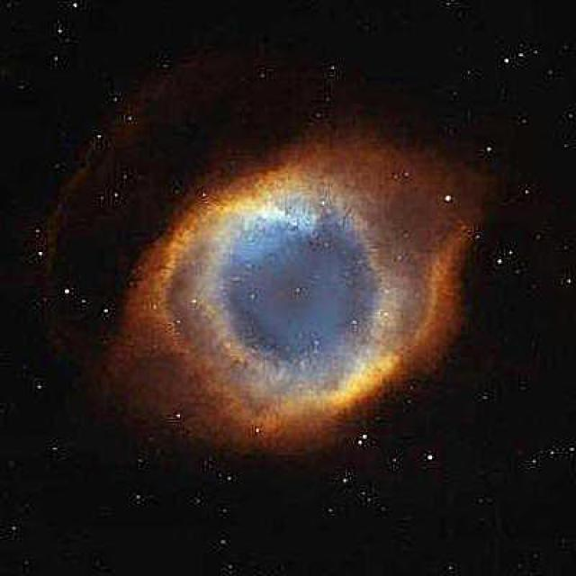

The Eye of God

This NASA photo of the Helix Nebula taken by the Hubble Space Telescope has been labeled the “Eye of God”.

